The State of Ohio,

Plaintiff,

**FILED**

**DELAWARE**

**MUNICIPAL COURT**

**2022-Jun-25 6:42 AM**

**CINDY DINOVO**

**CLERK**

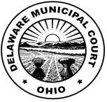

vs. Case No. 21CRB00615

Mark Borham,

Defendant.

**NOTICE OF HEARING**

This case is scheduled for a Final Pretrial on June 21, 2022 at 1:00 PM and a Jury Trial on June 25, 2022 at **8:15 A.M.** in Courtroom B.

cc: Prosecutor

Mark Borham